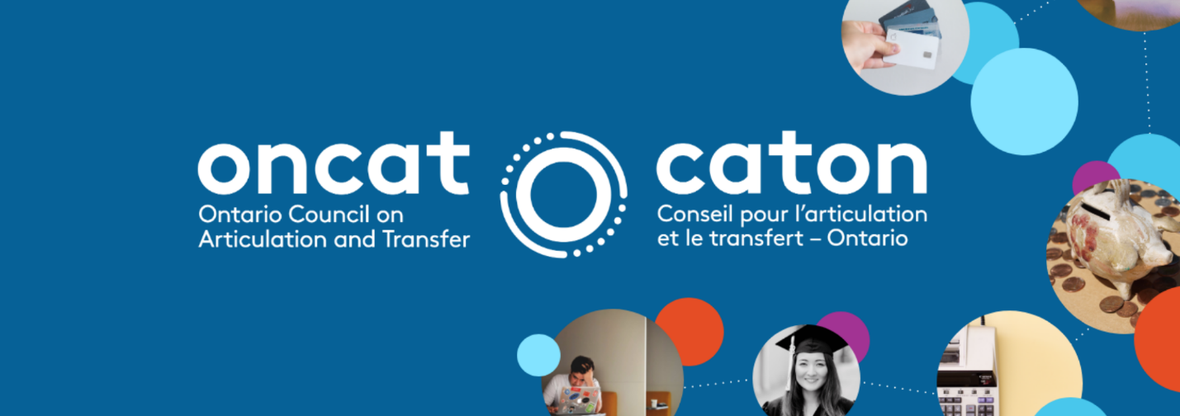
PROJECT SNAPSHOT
Expanding pathways to postsecondary for Nishnawbe Aski Nation and other learners in community wellness

Type: Pathway Development
Project Number: 2020-24 or P2024
Project Lead: Oshki-Pimache-O-Win: The WenJack Education Institute
Collaborators: Canadore College of Applied Arts and Technology, Sault College of Applied Arts and Technology, Saint Paul University

Project Summary
2 year College Diploma towards an Honours Bachelor of Arts Degree:
- Social Service Worker-Native Specialization (Sault) to the Honours Bachelor of Arts Degree in Human Relations & Spirituality (SPU)
- Social Service Worker-Indigenous Specialization (Sault) to the Honours Bachelor of Arts Degree in Human Relations & Spirituality (SPU)
- Indigenous Wellness and Addictions Prevention (Canadore) to the Honours Bachelor of Arts Degree in Human Relations & Spirituality (SPU)
- Early Childhood Education (Canadore) to the Honours Bachelor of Arts Degree in Human Relations & Spirituality (SPU)

Honours Bachelor of Arts Degree to a 2-year College Diploma:
- Honours Bachelor of Arts Degree towards the Social Service Worker-Native Specialization Program (Sault) Honours Bachelor of Arts Degree towards the Social Service Worker-Indigenous Specialization Program (Sault)
- Honours Bachelor of Arts Degree towards the Indigenous Wellness and Addictions Prevention Program (Canadore)
- Honours Bachelor of Arts Degree towards the Early Childhood Education Program (Canadore)

Project Rationale
This project was thought out and brought forward to bring awareness and the need for mental health support.
Students who complete the college and then venture into the university degree program can pursue professional certification in the Ontario College of Psychotherapists.
Graduates would return to communities and practice social work skills where evidence has shown high numbers of drug abuse, violence, and suicide among its members.

Main Collaborators
SPU:
- Director of the Counselling program, Professor Martin Blais Saint Paul University Pauline Belanger, Manager of Academic Programs Saint Paul University
- Jean-Marc Barrette, Vice Rector Academic and Research
- George Smith, Dean of the Faculty of Human Sciences and Philosophy
- Robin Saliba, Coordinator of Academic Programs and faculty

Results
Pathways where a college graduate of the IWAP (Indigenous Wellness and Addictions Program) or the Social Servicer Worker program can enter into the H.B.A. degree program at Saint Paul University and gain a degree in Humanity and Spirituality.

Key Steps
Course evaluations from all of the partners needed to be examined closely. It was important that all partners involved would find agreement in regards to an acceptable level of advanced standing from those who graduated from the college partners in pursuing the university degree.

And also, those who graduated from the university who may have wanted to pursue the diploma programs under the partner college. Values for the courses completed aided in the students and their ability to complete their studies in a shorter amount of time.

Pathways Created
2 year College Diploma towards an Honours Bachelor of Arts Degree:
Social Service Worker-Native Specialization (Sault) to the Honours Bachelor of Arts Degree in Human Relations & Spirituality (SPU)
Social Service Worker-Indigenous Specialization (Sault) to the Honours Bachelor of Arts Degree in Human Relations & Spirituality (SPU)
Indigenous Wellness and Addictions Prevention (Canadore) to the Honours Bachelor of Arts Degree in Human Relations & Spirituality (SPU)
Early Childhood Education (Canadore) to the Honours Bachelor of Arts Degree in Human Relations & Spirituality (SPU)

Honours Bachelor of Arts Degree to a 2-year College Diploma:
Honours Bachelor of Arts Degree towards the Social Service Worker-Native Specialization Program (Sault) Honours Bachelor of Arts Degree towards the Social Service Worker-Indigenous Specialization Program (Sault)
Honours Bachelor of Arts Degree towards the Indigenous Wellness and Addictions Prevention Program (Canadore)
Honours Bachelor of Arts Degree towards the Early Childhood Education Program (Canadore)

Challenges
The one unique challenge faced during this project was the fact that we were not able to meet in person due to COVID 19 restrictions. We were scheduled to have an in-person meeting halfway through the project to discuss any problems or concerns that may have arisen. But, due to travel restrictions that were in place, we were able to complete the necessary touch base meetings through Zoom.

Student Outcomes
Reduces the number of years to get a university degree by 2 years, reduces debt thus financial savings, students out on the job market faster or move onto graduate studies at a quicker pace.

Student Credential
Lowers the burden of debt on the student, allows the students to enter the job market or pursue graduate studies at a faster pace.

Student Time Savings
Time savings for students would be that two years of university studies are the total amount of studies required if they completed the college diploma program.

Student Financial Savings
This pathway will give students savings in regards to the paying of university tuition costs. Under the pathway, the student pays university tuition X 2 years, rather then a student without the college diploma paying university tuition X 4 years.

Student Flexibility
This pathway will ensure that the time required to complete the university is shorter as they will have already graduated from the college programs.Those who complete the HBA degree at Saint Paul University can further pursue a MA degree which will enable the student to register into the Ontario College of Psychotherapists.

Student Work Alignment
Yes, this will lead to students being able to fulfill voids in the high demand for professional therapists to help deal with the growing concerns within their communities. These communities deal with high number of cases of suicide, physical and mental abuse, and alcoholism. Pursuing these studies will give students to the necessary tools to help in aiding and trying to assist in these pressing social issues within their community.

Tools and Resources
An articulation agreement was established between Saint Paul University and Canadore College during the period of this project.

